Q.1

a)

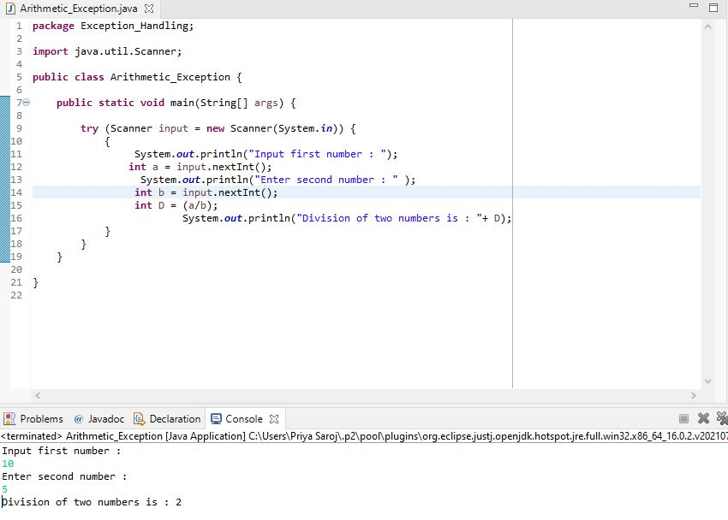

b)

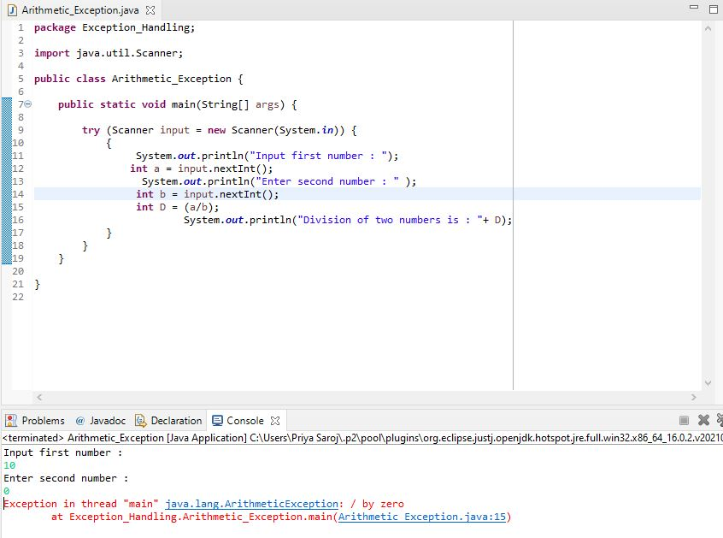

c)

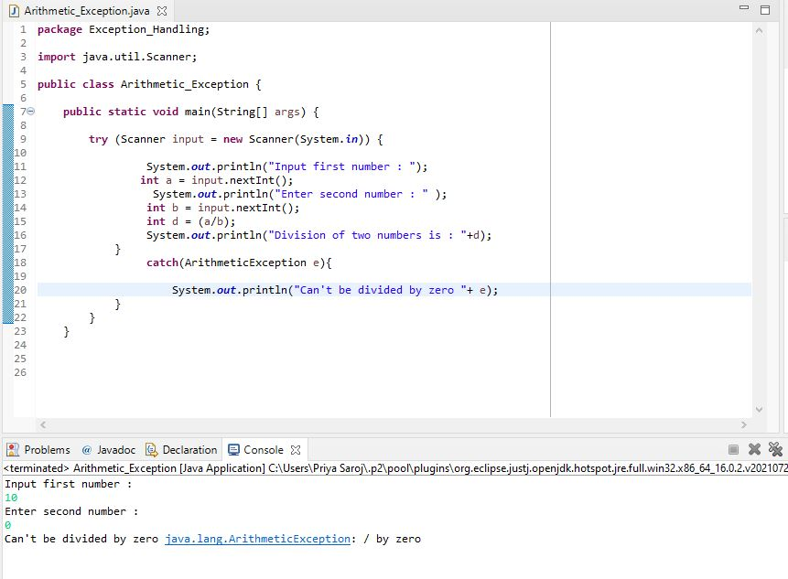

Q.2

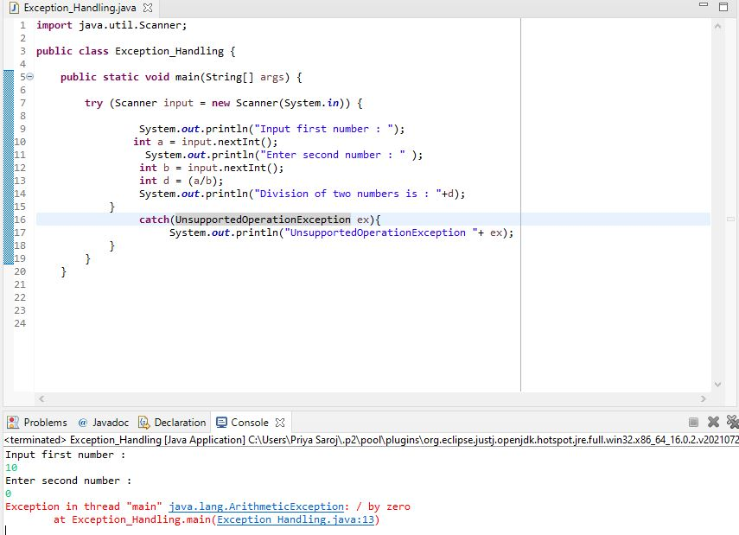

Q.3

a)

**class** InsufficientBalanceException **extends** Exception

{

**private** **static** **final** **long** ***serialVersionUID*** = 1L;

**private** **double** amount;

**public** InsufficientBalanceException(**double** amount)

{

**this**.amount = amount;

}

**public** **double** getAmount()

{

**return** amount;

}

}

**class** Account

{

**long** id;

**private** **double** balance;

**public** Account (**int** id) {

**this**.id=id;

}

**public** **void** deposit(**double** amount)

{

balance += amount;

}

**public** **void** withdraw(**double** amount) **throws** InsufficientBalanceException

{

**if**(amount < balance)

{

balance -= amount;

}

**else** {

**double** needs = amount - balance;

**throw** **new** InsufficientBalanceException(needs);

}

}

**public** **double** getBalance() {

**return** balance;

}

}

**public** **class** Savings_Account {

**public** **static** **void** main(String[] args) {

**int** id;

Account a = **new** Account(id=123456789);

System.***out***.println("Account id "+id);

System.***out***.println("Depositing Rs 2000...");

a.deposit(2000);

**try** {

System.***out***.println("Withdrawing Rs 2100... ");

a.withdraw(2100);

}

**catch**(InsufficientBalanceException e) {

System.***out***.println("Insufficient Balance| you need more " +e.getAmount() + " to get money");

}

}

}

OUTPUT:

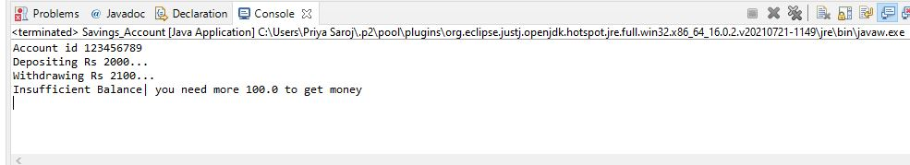

b)

**import** java.util.Scanner;

**public** **class** IllegalBankTransactionException **extends** Exception {

**private** **static** **final** **long** ***serialVersionUID*** = 1L;

**static** **void** amount() **throws** IllegalBankTransactionException

{

**long** id;

**double** balance = 0, deposit, withdraw ;

Scanner depo = **new** Scanner(System.***in***);

System.***out***.println("Deposit an amount");

deposit =depo.nextInt();

balance -= deposit;

Scanner wd = **new** Scanner(System.***in***);

System.***out***.println("Withdraw an amount");

withdraw =wd.nextInt();

balance -= withdraw;

**if** (withdraw<0)

{

**throw** **new** IllegalBankTransactionException();

}

**else**

System.***out***.println(balance);

}

**public** **static** **void** main(String[] args) {

**try**

{

*amount*();

}

**catch**(IllegalBankTransactionException ex)

{

System.***out***.println("Entering the Negative withdraw amount is not allowed");

}

}

}

OUTPUT:

